Apache Spark Multi-Node Cluster Setup (Spark 3.5.4)

1. Download and Extract Spark
To set up a multi-node cluster, first, download and install Spark on the master node.

Steps:
- Download Spark 3.5.4 from the official Apache website:
wget https://www.apache.org/dyn/closer.lua/spark/spark-3.5.4/spark-3.5.4-bin-hadoop3.tgz
- Extract the downloaded archive:
tar -xvzf spark-3.5.4-bin-hadoop3.tgz
- Move the extracted folder to the /opt directory for a standardized location:
mv spark-3.5.4-bin-hadoop3 /opt/spark

2. Configure Environment Variables

Purpose:
Setting environment variables ensures that Spark binaries and libraries are accessible from anywhere in the terminal, preventing the need to specify full paths repeatedly.

Steps:
- Open the .bashrc file:
nano ~/.bashrc
- Add the following lines at the end of the file:
export SPARK_HOME=/opt/spark
export PATH=$SPARK_HOME/bin:$SPARK_HOME/sbin:$PATH
export PYSPARK_PYTHON=python3
- Apply the changes so they take effect immediately:
source ~/.bashrc

3. Configure Spark Cluster

A. Edit spark-env.sh
- Copy the template file to make modifications:
cp /opt/spark/conf/spark-env.sh.template /opt/spark/conf/spark-env.sh
- Edit the file:
nano /opt/spark/conf/spark-env.sh
- Add the following configurations:
export SPARK_WORKER_MEMORY=2g # Limits memory usage per worker to avoid resource exhaustion
export SPARK_DRIVER_MEMORY=2g # Ensures Spark driver has enough memory to process tasks
export SPARK_EXECUTOR_MEMORY=2g # Defines executor memory to balance efficiency and performance
export SPARK_MASTER_HOST=172.16.72.36 # Master Node IP
export SPARK_MASTER_PORT=7077
export SPARK_WORKER_CORES=2 # Allocates CPU cores per worker to balance performance
export SPARK_WORKER_INSTANCES=2 # Start 2 worker instances (if needed)
export SPARK_MASTER_WEBUI_PORT=9090 # Allows web UI access for monitoring
export SPARK_WORKER_WEBUI_PORT=8081
export SPARK_LOG_DIR=/opt/spark/logs # Centralized logging for debugging
export SPARK_WORKER_DIR=/opt/spark/work # Defines worker directories for temporary storage
export JAVA_HOME="/usr/lib/jvm/java-11-openjdk-amd64" # Ensures Spark uses the correct Java version
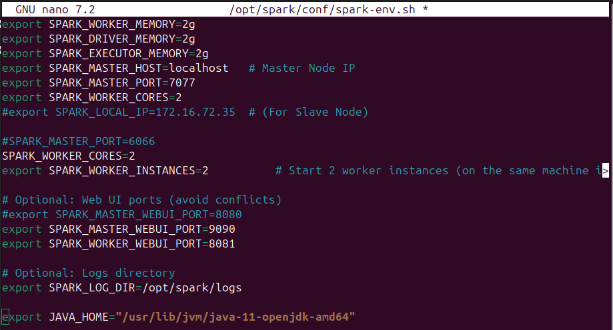

B. Configure Worker Nodes
- Edit the slaves file to specify worker nodes:
nano /opt/spark/conf/slaves
- Add the worker node’s hostname or IP:
slave1 # Replace with actual hostname or IP of worker nodes
- Ensure master’s hostname is added to /etc/hosts on each slave node for proper name resolution.

4. Set Up SSH for Passwordless Login

Purpose:
Passwordless SSH is required so that the master node can start Spark services on worker nodes remotely, ensuring seamless cluster management.

Steps:
- On the master node, generate an SSH key (press Enter for default settings):
ssh-keygen -t rsa
- Copy the key to all worker nodes to enable passwordless access:
ssh-copy-id -i ~/.ssh/id_rsa.pub username@slave1
ssh-copy-id -i ~/.ssh/id_rsa.pub iiitdmk-aidslab-03@172.16.72.26
- Test SSH access to ensure connectivity:
ssh slave1

5. Start Spark Cluster

Method 1: Recommended for Multi-Node Clusters
- Start the Spark master on the master node:
./sbin/start-master.sh
- Start all workers from the master node:
./sbin/start-slaves.sh

Method 2: Manual Start Per Worker Node
If the workers do not start automatically, manually start them using:
./sbin/start-slave.sh spark://172.16.72.36:7077

Verify the Cluster Setup
- Open the Spark Master UI in a browser:
http://172.16.72.36:9090
- Check running Spark processes using:
jps
Expected output on the master node:
1234 Master
5678 Worker
Expected output on the worker node:
9101 Worker

6. Stop Spark Cluster
To stop the cluster and free resources, run:
stop-all.sh

7. Issues Encountered

A. Slave Not Connecting to Master

Issue:
The slave node was not registering with the master.

Fixes:
- Ensured both systems were on the same network.
- Restarted Spark services.
- Verified SPARK_MASTER_HOST in spark-env.sh was correctly set.

B. Spark UI Not Showing Workers

Issue:
Workers were not appearing in the Spark UI.

Fixes:
- Verified that SPARK_MASTER_HOST was correctly set in spark-env.sh.
- Used IP addresses instead of hostnames in configuration files.
- Restarted the Spark services after configuration changes.

-----------

Differences Between Multi-Node and Single-Node Spark Setup:

In Single Node Setup

- No SSH Key Sharing
  - In a single-node setup, there is no need to generate and copy SSH keys to other machines.
- No slaves File Configuration
  - The conf/slaves file is not required since there are no worker nodes to manage separately.
- SPARK_MASTER_HOST Can Be localhost
  - Instead of setting an explicit IP, SPARK_MASTER_HOST=localhost can be used.

References
https://github.com/darth-anish/setup-single-node-cluster-spark?tab=readme-ov-file
https://spark.apache.org/docs/latest/cluster-overview.html
https://aws.plainenglish.io/how-to-setup-install-an-apache-spark-3-1-1-cluster-on-ubuntu-817598b8e198

